**PROBLEM STATEMENT**

This program will calculate the gross sales of a movie that a box office makes in one night and also calculate how much profit the box office and the distributor makes in that night.

**Output Display**

Movie Name Star Wars

Adult Tickets Sold 500

Child Tickets Sold 300

-------------------------------------------------------------------------

Total Sales $3,425.00

Net Box Office Profit $685.00

Amount Paid to Distributor $2,740.00

**Structure Chart**

Display distributor profit

Display Box Office Profit

Display Total Sales

Output

Distributor profit

Box office profit

Total Sales

Calculate

Child tickets

Movie Title

Adult Tickets

Input

Box Office Program

**Pseudo Code**

Start of Algorithm for Box Office Program  
1. Input  
2. Calculate  
3. Output  
End of Algorithm for Box Office Program

**Flowchart for Input**

Start

Prompt the user and ask for movie title

**Pseudo Code**

Start of Algorithm for Input  
1. Prompt user and ask for MovieTitle  
2. Read in MovieTitle  
3. Prompt user and ask for AdultTickets  
4. Read in AdultTickets  
5.Prompt user and ask for ChildTickets  
6. Read in ChildTickets  
End of Algorithm for Input

Prompt the user and ask for adult tickets sold

Read in movie title

End

Read in child tickets sold

Prompt the user and ask for child tickets sold

Read in adult tickets sold

**Flowchart for Calculate**

Start

**Pseudo Code**

Start of Algorithm for Calculate  
 1. TotalSales = (AdultTickets * 5.50) + (ChildTickets * 2.25)  
 2. BoxOfficeProfit = TotalSales * 0.20  
 3. DistributorProfit = TotalSales * 0.80  
 End of Algorithm for Calculate

Write a formula for Total Sales

End

DistributorProfit = TotalSales * 0.80

Write a formula for Distributor Profit

BoxOfficeProfit = TotalSales * 0.20

Write a formula for Box Office Profit

TotalSales = (AdultTickets * 5.50) + (ChildTickets * 2.25)

**Flowchart for Output**

Start

End

Display Total Sales

Display Total Sales

Display Total Sales

**Pseudo Code**

Start of Algorithm for Output  
1. “Total Sales for the night: “  
2. “Box Office Profit:”  
3. “Amount Paid to Distributor: “  
End of Algorithm for Output

**INPUT**

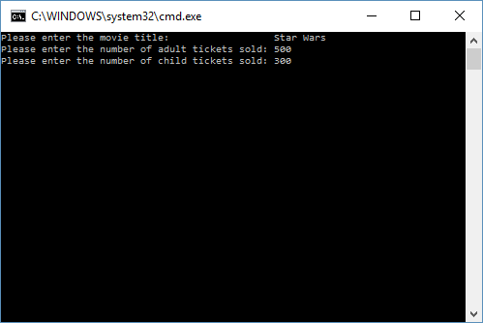

**OUTPUT**

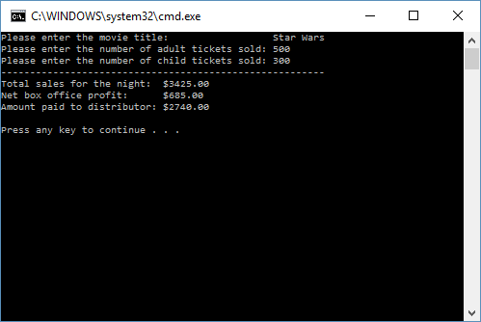

**User Instructions**

This program is designed to calculate how much revenue was generated in one night at a box office, and also how much profit was made by the box office and how much of the total sales went to the distributor. The program will first ask you what the title of the movie was, simply enter the name of the movie that generated the funds for that night. Next, it will ask you how many adult tickets were sold to that particular movie. The user will then enter the number of adult tickets that were sold to that movie on that night. Finally, it will ask you how many children’s tickets were sold that night. The user will then enter the number of child tickets that were sold on that night. After you input these three things the program will automatically calculate the total sales for that night, how much profit the box office made, and how much money was paid to the distributor.

**Comment**

Wow it feels really good to be finished with really the first program I’ve done pretty much on my own. I didn’t realize that you experience a rollercoaster of emotions when you program. When you finish your program you feel a sense of relief that you are done, but when you go to run it and something goes wrong you feel a sense of confusion and curiosity because you don’t know where the problem could be. Then you feel a rush of frustration when you can’t find the problem. After minutes and hours of searching you get that feeling of realization and have an “AHA!” moment when you find the problem. Finally, back to the sense of relief and a sense of being proud of what you accomplished when you run your program and everything goes right. I’m really enjoying what I’m doing and I can’t wait to learn more and I’m excited about making this my future.